**Network Design for Huhtamaki India Ltd.**

*Mini Project Report for Network Design Lab submitted in partial fulfilment*

*of the requirement for the degree of*

B.E. (Information Technology)

Submitted By

**Patil Vinayak Sanjay**

**Rahate Rohan Eknath**

**Mhatre Suyash Balaram**

Under the Guidance of

**Ms. Swati Sinha**

Department of Information Technology



Mahatma Gandhi Mission’s

**College of Engineering and Technology**

(Affiliated to University of Mumbai and Approved by, AICTE, New Delhi.)

Plot No. 1, 2, Sion - Panvel Expressway, Sector 18, Kamothe, Navi Mumbai, Maharashtra 410209 Website : [www.mgmmumbai.ac.in](http://www.mgmmumbai.ac.in/)

**Department of Information Technology**

**2021-2022**

CERTIFICATE OF APPROVAL

For

**Mini Project Report for Network Design Lab**

This is to Certify that

**Patil Vinayak Sanjay**

**Rahate Rohan Eknath**

**Mhatre Suyash Balaram**

Have successfully carried out Mini Project entitled

“**Network Design for Huhtamaki India Ltd.**”

in partial fulfilment of the degree course in

Information Technology

As laid down by the University of Mumbai during the academic year

2021-2022

Under the Guidance of

**Ms. Swati Sinha**

Signature of Project Guide Head of Department

Examiner 1 Examiner 2 Principal

**Index:**

|  |  |  |
| --- | --- | --- |
| Serial no | Topic | Pages |
| 1 | Problem Statement | 4 |
| 2 | Existing Design | 5 |
| 3 | Network Block Diagram | 6 |
| 4 | Design | 7 |
| 5 | Packet Tracer Screenshots | 8 |
| 6 | IP Table | 9-11 |
| 7 | Bill of Materials | 12 |
| 8 | Conclusion | 13 |
| 9 | Reference | 13 |

**Problem Statement**

This report is a case study that analyses the network infrastructure of Huhtamaki India Ltd. The report also provides complete details of the existing network, their flaws and the resolved design approach that will effectively satisfy the user requirements with high quality of services (QoS).

**Existing infrastructure**

Huhtamaki India Ltd. is a leading provider of primary consumer packaging & decorative labelling solutions in India, and part of Huhtamaki Oyj, a Finnish-based global food packaging major.

Packing memorable experiences together with our customers and partners since 1935, today we are a total solutions company with a Pan-India presence, backed by 18 manufacturing sites and 5 customer support centers. The acquisitions and subsequent mergers of Webtech Labels Pvt Ltd.  & Positive Packaging Industries Ltd., as well as the acquisition of the India operations of Ajanta Labels have strengthened HPPL’s leadership in flexible and labelling solutions.

With a passion to protect what is good, we offer unique pack designs and formats through a comprehensive portfolio of flexible packaging solutions. Our solutions include barrier and recyclable laminates, specialized pouching like shaped, 5 and 6 panel pouches, thermoforms, decorative labels, digitally printed laminates for pack personalization and tube laminates.

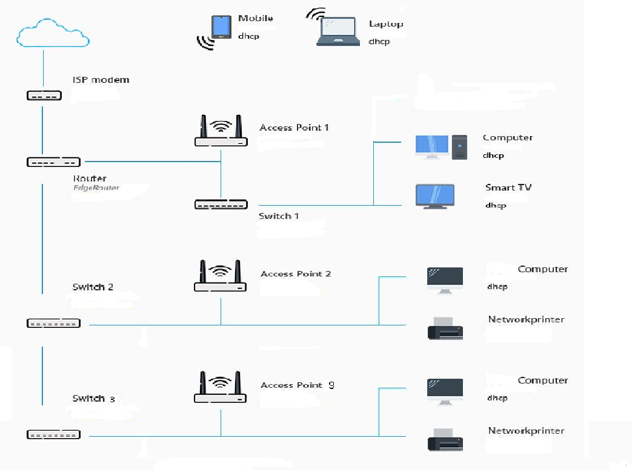

**Fig. Block Diagram of Existing System**

**Design**

* There is a single main building consists of six departments.
* The main building has 2 floors and a ground floor.
* The servers are situated in the ground floor of the building.
* We have used different Servers, Routers, Switches, Access Points, Printers, IP-Phones, Personal Computers and Laptops.
* For system connection we used CAT6 cables – RJ45 connector and for IP-Phones connection Serial DTE cable – RJ11 connector is used.
* We have used four routers in such a way that three separate routers for each floor and one main router connected to server room located at ground floor.
* In the network, total eight switches are used. Each floor has three departments and separate switch is allotted to that particular department. One switch is used at ground floors server room which gets connection from main router and one separate switch is used for IP-Phones connection.
* All computers in the building are connected via CAT6 cable and the laptops are wirelessly connected to the access points. We have used three access points; each floor has one single access point covering the range of 500m.
* We have provided printer to each department’s office and their working areas. Each floor has a conference room so the separate printer is also provided to it and at the ground floor there are only three printers are installed, one for head office, one for reception and last one for conference room.

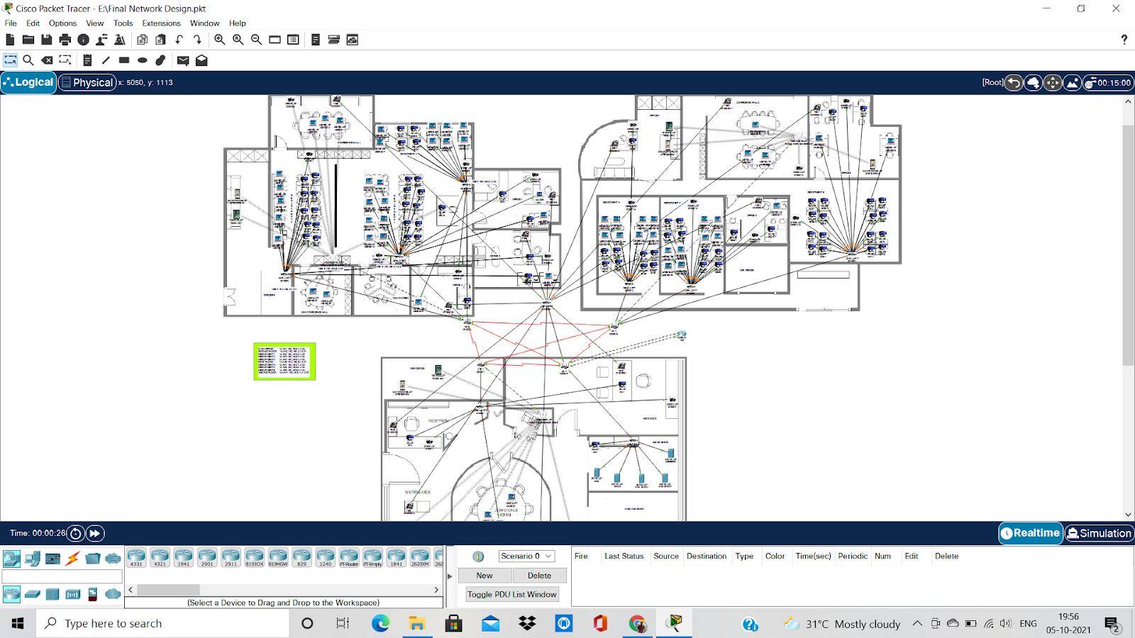

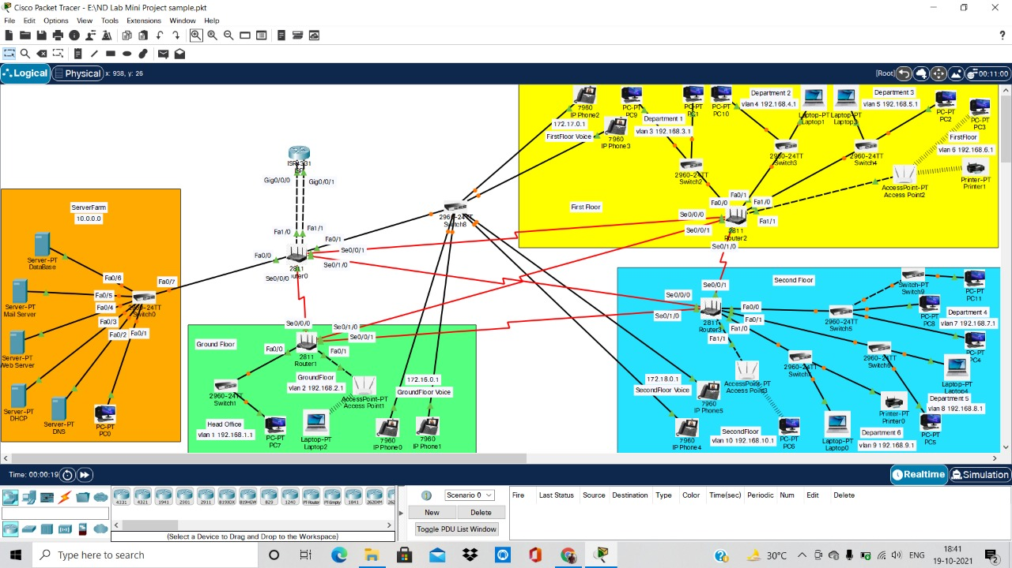

**Fig. Main Network Design**

|  |  |  |  |  |
| --- | --- | --- | --- | --- |
| Components | *Interface* | *IP Address* | *Subnet Mask* | *End Devices* |
| DNS Server | Fa0 | 10.0.0.5 | 255.0.0.0 | Switch0 |
| DHCP Server | Fa0 | 10.0.0.10 | 255.0.0.0 | Switch0 |
| Web Server | Fa0 | 10.0.0.8 | 255.0.0.0 | Switch0 |
| Mail Server | Fa0 | 10.10.10.2 | 255.0.0.0 | Switch0 |
| Database Server | Fa0 | 10.0.0.25 | 255.0.0.0 | Switch0 |
| ISP | Gig0/0/0 | 77.77.77.2 | 255.0.0.0 | Router0 |
| Gig0/0/1 | 88.88.88.2 | 255.0.0.0 | Router0 |
| Router0 | Fa0/0 | 10.0.0.1 | 255.0.0.0 | Switch0 |
| Fa0/1.11 | 172.16.0.1 | 255.255.0.0 | Switch8 |
| Fa0/1.12 | 172.17.0.1 | 255.255.0.0 | Switch8 |
| Fa0/1.13 | 172.18.0.1 | 255.255.0.0 | Switch8 |
| Fa1/0 | 77.77.77.1 | 255.0.0.0 | ISP |
| Fa1/1 | 88.88.88.1 | 255.0.0.0 | ISP |
| Se0/0/0 | 20.0.0.1 | 255.0.0.0 | Router1 |
| Se0/0/1 | 30.0.0.1 | 255.0.0.0 | Router2 |
| Se0/1/0 | 40.0.0.1 | 255.0.0.0 | Router3 |
| Router1 | Fa0/0 | 192.168.1.1 | 255.255.255.0 | Switch1 |
| Fa0/1 | 192.168.2.1 | 255.255.255.0 | Access Point 1 |
| Se0/0/0 | 20.0.0.2 | 255.0.0.0 | Router0 |
| Se0/0/1 | 50.0.0.1 | 255.0.0.0 | Router2 |
| Se0/1/0 | 70.0.0.1 | 255.0.0.0 | Router3 |
| Router2 | Fa0/0 | 192.168.3.1 | 255.255.255.0 | Switch2 |
| Fa0/1 | 192.168.4.1 | 255.255.255.0 | Switch3 |
| Fa1/0 | 192.168.5.1 | 255.255.255.0 | Switch4 |
| Fa1/1 | 192.168.6.1 | 255.255.255.0 | Access Point 2 |
| Se0/0/0 | 30.0.0.2 | 255.0.0.0 | Router0 |
| Se0/0/1 | 70.0.0.2 | 255.0.0.0 | Router1 |
| Se0/1/0 | 60.0.0.1 | 255.0.0.0 | Router3 |
| Router3 | Fa0/0 | 192.168.7.1 | 255.255.255.0 | Switch5 |
| Fa0/1 | 192.168.8.1 | 255.255.255.0 | Switch6 |
| Fa1/0 | 192.168.9.1 | 255.255.255.0 | Switch7 |
| Fa1/1 | 192.168.10.1 | 255.255.255.0 | Access Point 3 |
| Se0/0/0 | 40.0.0.2 | 255.0.0.0 | Router0 |
| Se0/0/1 | 50.0.0.2 | 255.0.0.0 | Router1 |
| Se0/1/0 | 60.0.0.2 | 255.0.0.0 | Router2 |

**IP Tables**

|  |  |  |  |  |
| --- | --- | --- | --- | --- |
| VLAN | Name | IP Address | Subnet Mask | End Devices |
| VLAN 0 | Server Farm | 10.0.0.0 | 255.0.0.0 | Switch0 |
| VLAN 1 | Head Office | 192.168.1.0 | 255.255.255.0 | Switch1 |
| VLAN 2 | Ground Floor | 192.168.2.0 | 255.255.255.0 | Access Point1 |
| VLAN 3 | Department 1 | 192.168.3.0 | 255.255.255.0 | Switch2 |
| VLAN 4 | Department 2 | 192.168.4.0 | 255.255.255.0 | Switch3 |
| VLAN 5 | Department 3 | 192.168.5.0 | 255.255.255.0 | Switch4 |
| VLAN 6 | First Floor | 192.168.6.0 | 255.255.255.0 | Access Point2 |
| VLAN 7 | Department 4 | 192.168.7.0 | 255.255.255.0 | Switch5 |
| VLAN 8 | Department 5 | 192.168.8.0 | 255.255.255.0 | Switch6 |
| VLAN 9 | Department 6 | 192.168.9.0 | 255.255.255.0 | Switch7 |
| VLAN 10 | Second Floor | 192.168.10.0 | 255.255.255.0 | Access Point3 |
| VLAN 11 | IP Phone-Ground Floor | 172.16.0.0 | 255.255.0.0 | Switch8 |
| VLAN 12 | IP Phone-First Floor | 172.17.0.0 | 255.255.0.0 | Switch8 |
| VLAN 13 | IP Phone-Second Floor | 172.18.0.0 | 255.255.0.0 | Switch8 |

|  |  |  |  |
| --- | --- | --- | --- |
| Devices | VLAN | VLAN Name | Port Assignment |
| Switch0 | VLAN 0 | Server Farm | Fa0/1-12 |
| Switch1 | VLAN 1 | Head Office | Fa0/1-24 |
| Switch2 | VLAN 3 | Department 1 | Fa0/1-24 |
| Switch3 | VLAN 4 | Department 2 | Fa0/1-24 |
| Switch4 | VLAN 5 | Department 3 | Fa0/1-24 |
| Switch5 | VLAN 7 | Department 4 | Fa0/1-24 |
| Switch6 | VLAN 8 | Department 5 | Fa0/1-24 |
| Switch7 | VLAN 9 | Department 6 | Fa0/1-24 |
| Switch8 | VLAN 11 | IP Phone-Ground Floor | Fa0/1-8 |
|  | VLAN 12 | IP Phone-First Floor | Fa0/9-16 |
|  | VLAN 13 | IP Phone-Second Floor | Fa0/17-24 |

|  |  |  |
| --- | --- | --- |
| Floor | Telephone Name | Telephone Number |
| Ground Floor | **Head Office** | **1001** |
|  | **Reception** | **1002** |
|  | **Conference Room** | **1003** |
|  | **Waiting Area** | **1004** |
| First Floor | **Office 1** | **2001** |
|  | **Office 2** | **2002** |
|  | **Office 3** | **2003** |
|  | **Conference Room** | **2004** |
| Second Floor | **Office 4** | **3001** |
|  | **Office 5** | **3002** |
|  | **Office 6** | **3003** |
|  | **Conference Room** | **3004** |

**Bill of material (BOM)**

**(Will be good from practical implementation)**

|  |  |  |  |  |
| --- | --- | --- | --- | --- |
| Serial No. | Name Of Hardware Used | No. Of Hardware Used | Approximate Price/component | Total Price |
| 1 | Server | 5 | 1,00,000/- | 5,00,000 |
| 2 | Router | 3 | 5,000/- | 15,000 |
|  |  | 1 | 8,000/- | 8,000 |
| 3 | Switch | 10 | 8,500/- | 85,000 |
| 4 | Access Point | 3 | 2,500/- | 7,500 |
| 5 | PC | 250 | 30,000/- | 75,00,000 |
| 6 | Laptop | 200 | 25,000/- | 50,00,000 |
| 7 | Printer | 17 | 20,000/- | 3,40,000 |
| 8 | IP Phone | 15 | 4,000/- | 60,000 |
| 9 | Cable (Cat6) | 10 Bundles (305m) | 5,000/- per bundle | 50,000 |
| 10 | Cable (Serial DTE) | 500m | 1200/- per meter | 60,000 |
| 11 | RJ45 Connector | 2000 Pieces | 350/- per packet (100 Pieces) | 7,000 |
| 12 | RJ11 Connector | 100 Pieces | 300/- per packet (50 Pieces) | 600 |
| Total Cost |  | | | **1,36,33,100/-** |

**Conclusion**

In this project the design of the existing system has been improved, so that it is reliable, easily accessible, secure and having capability to adapt new features and modification in the network as it uses different types of IP addresses for various departments and the network is separated into different IP classes.

**References**

* Bradley, M. 2017. Wireless Standards 802.11a, 802.11b/g/n, and 802.11ac. WWW document. Available at: <https://www.lifewire.com/wireless-standards802-11a-802-11b-g-n-and-802-11ac816553> [Accessed 01 April 2017].
* Abdelkarim, R. 2006. Security in Wireless Data Networks: A Survey Paper. WWW document. Available at <http://www.cs.wustl.edu/~jain/cse57406/ftp/wireless_security/index.html> [Accessed 20 April 2017].
* Alexandra, G. 2015. Getting Familiar with Wi-Fi Channels? WLAN Back to Basics. WWW document. Available at : <http://boundless.aerohive.com/experts/WLANChannelsExplained.html> [Accessed 26 March 2017].
* Cisco. 2011. Wireless LAN Controller Web Authentication Configuration Example. WWW document. Available at : <http://www.cisco.com/c/en/us/support/docs/wirelessmobility/wlansecurity/69340-web-auth-config.html> [Accessed 20 April 2017].